Original

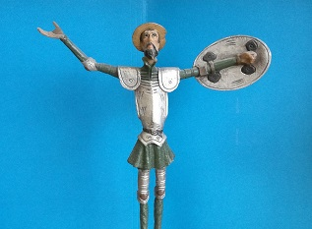

Grayscale

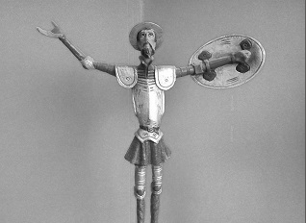

Rotated

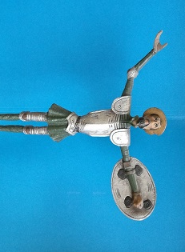

Blurred

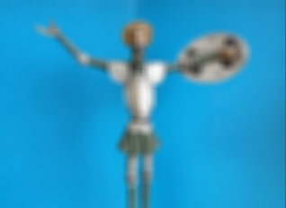

Enlarged

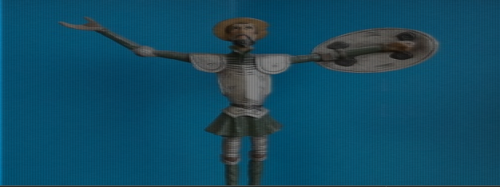

Edges

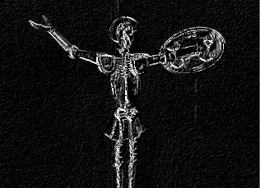

Blue screening

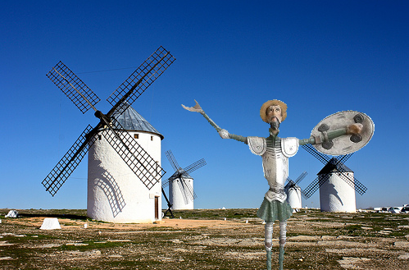

Code available on github as well!

<https://github.com/jgcaballero/ComputerVision/tree/master/Extra%20Credit>

import numpy as np

import cv2

from scipy.interpolate import interp1d

#a)

**def grayscale():**

image = cv2.imread('images/quijote_lr.jpg')

grayValue = 0.07 * image[:,:,2] + 0.72 * image[:,:,1] + 0.21 * image[:,:,0]

gray_img = grayValue.astype(np.uint8)

cv2.imshow('grayscale',gray_img)

#b)

**def rotate():**

image2 = cv2.imread('images/quijote_lr.jpg')

upside = image2[::-1,::1]/255

row = upside.shape[0]

col = upside.shape[1]

rotated = np.zeros((col,row,3))

print('row',upside.shape[0])

print('col',upside.shape[1])

for y in range(upside.shape[0]):

for x in range(upside.shape[1]):

rotated[x,y] = upside[y,x]

print(rotated)

cv2.imshow('rotated',rotated)

#c)

**def box_filter():**

image = cv2.imread('images/quijote_lr.jpg')

box_size = 10

kernel = np.ones((box_size,box_size))/(box_size*box_size)

blur = np.abs(cv2.filter2D(image,-1,kernel))

cv2.imshow('box',blur)

#d)

**def enlarge():**

image = cv2.imread('images/quijote_lr.jpg')

new_row = image.shape[0]

new_col = image.shape[1]*2

enlarge = np.zeros((new_row, new_col,3))

for y in range(image.shape[0]):

for x in range(image.shape[1]):

if(x != image.shape[1] - 2):

enlarge[y,x*2] = image[y,x]

for y in range(enlarge.shape[0]):

for x in range(enlarge.shape[1]-2):

px0 = enlarge[y,x]

px1 = enlarge[y,x+2]

new_px = (px0 + px1)//2

enlarge[y,x+1] = new_px

for y in range(enlarge.shape[0]):

for x in range(enlarge.shape[1]-2):

px0 = enlarge[y,x]

px1 = enlarge[y,x+2]

new_px = (px0 + px1)//2

enlarge[y,x+1] = new_px

''' Using interp1d, did not know if this was allowed so I actually implemented my own 1step interpolation, they

came out looking very similar as well.'''

x = np.array(range(enlarge.shape[1]))

xnew = np.linspace(x.min(), x.max(), new_col)

f = interp1d(x,enlarge, axis=1)

cv2.imshow('enlarge',f(xnew)/255)

# cv2.imshow('enlarge',enlarge/255)

#e)

**def edges():**

image = cv2.imread('images/quijote_lr.jpg',0)

kernel_v = np.array([[-1,0,1],[-2,0,2],[-1,0,1]])

kernel_h = np.array([[-1,-2,-1],[0,0,0],[1,2,1]])

gray_frame_f = np.abs(cv2.filter2D(image,-1,kernel_v))+np.abs(cv2.filter2D(image,-1,kernel_h))

cv2.imshow('edges',gray_frame_f)

#2)

**def blue_bg():**

#SOURCE: https://docs.opencv.org/master/df/d9d/tutorial_py_colorspaces.html#gsc.tab=0

#https://stackoverflow.com/questions/38357141/identifying-green-circles-from-this-image/38357999#38357999

image = cv2.imread('images/quijote_lr.jpg')

windmill = cv2.imread('images/windmill.jpg')

hsv = cv2.cvtColor(image, cv2.COLOR_BGR2HSV)

black = np.array([0,0,0])

lower_blue = np.array([90,50,50])

upper_blue = np.array([110,255,255])

mask = cv2.inRange(hsv, lower_blue, upper_blue)

res = cv2.bitwise_and(image,image, mask= mask)

print(hsv)

for y in range(windmill.shape[0],0,-1):

for x in range(windmill.shape[1],0,-1):

if(x != 183 and y != 100):

if(np.all(res[y-101,x-184] == black)):

windmill[y-1,x-1] = image[y-101,x-184]

else:

break

if(y == 100):

break

# cv2.imshow('frame',image)

# cv2.imshow('mask',mask)

# cv2.imshow('res',res)

cv2.imshow('res',windmill)

image = cv2.imread('images/quijote_lr.jpg')

cv2.imshow('og',image)

grayscale()

rotate()

box_filter()

enlarge()

edges()

blue_bg()

cv2.waitKey(0)

cv2.destroyAllWindows()